Instructions for accessing ArcGIS Pro
Using UTEP authentication

- Type the following URL: utep.maps.arcgis.com
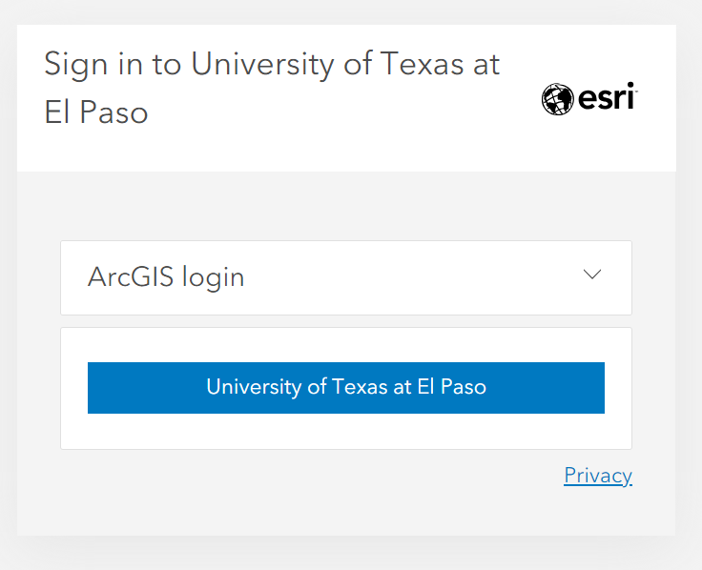
- Click on the University of Texas button and sign in with your UTEP email and password.
- Once logged in click your name at the top right of the page and select my settings

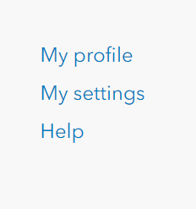

- Select licenses

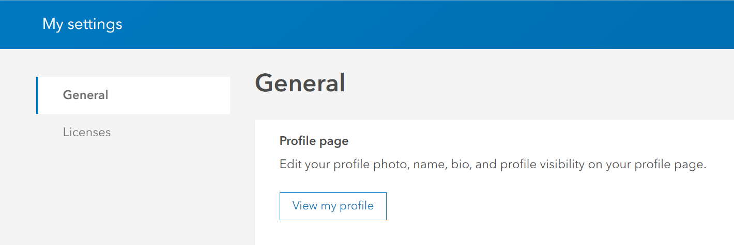

- At the right of the page download the software 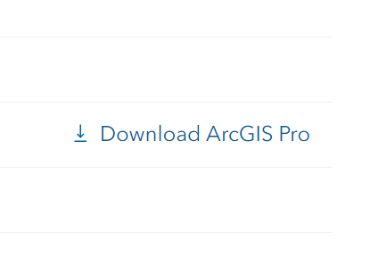
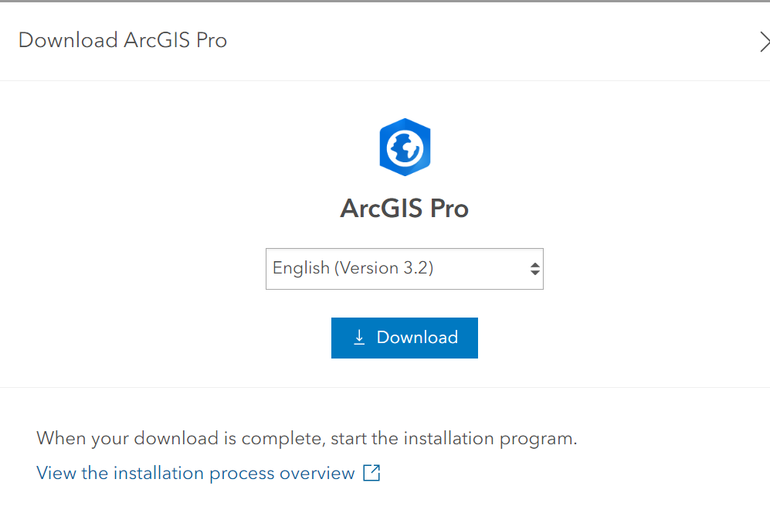
- Select Download. Before you run the installation you will need Microsoft DotNet6 installed.
- Once Pro’s installation is complete, run Pro and you should get the following:
